

**Sorbonne University**

**Master 2 BMC - Systems Immunology**

# Characterization of the inflammatory status in osteosarcoma by

***in silico* RNA-Seq analysis**

By

**HUYNH Minh-Anh**

September 2022

# Table of Contents

**List of Abbreviations**

## Acknowledgements

1. **Introduction 1**
2. **Objective and experimental principle 2**
3. **Methods 4**
   1. Data collection . . . . . . . . . . . . . . . . . . . . . . . . . . . . . . . . . . . . 4
   2. Normalization . . . . . . . . . . . . . . . . . . . . . . . . . . . . . . . . . . . . 4
   3. Construction of inflammatory groups . . . . . . . . . . . . . . . . . . . . . . . . 4
   4. Markers for osteosarcomas . . . . . . . . . . . . . . . . . . . . . . . . . . . . . 4
   5. MDS visualization and k-means clustering . . . . . . . . . . . . . . . . . . . . . 5
   6. Determination of cell population abundance . . . . . . . . . . . . . . . . . . . . . 5
   7. Identification of Differentially Expressed Genes (DEG) . . . . . . . . . . . . . . . 5
      1. Pathway Enrichment . . . . . . . . . . . . . . . . . . . . . . . . . . . . . 5
   8. Gene Set Enrichment Analysis (GSEA) . . . . . . . . . . . . . . . . . . . . . . . 6
   9. Statistical Testing . . . . . . . . . . . . . . . . . . . . . . . . . . . . . . . . . . 6
4. **Results 7**
   1. Determination of inflammatory groups representing intratumor inflammatory status 7
   2. Characterization of osteosarcomas associated to inflammatory status . . . . . . . . 7
   3. Characterization of intra-tumor inflammation associated to inflammatory status . . 10
      1. Relationship with ESTIMATE and inflammatory signatures . . . . . . . . 10
      2. Immune abundance by immune deconvolution algorithm . . . . . . . . . . 10
      3. Survival curve . . . . . . . . . . . . . . . . . . . . . . . . . . . . . . . . 13
      4. Similarity of inflammatory signatures . . . . . . . . . . . . . . . . . . . . 14
   4. Biological mechanisms underlying the inflammatory groups . . . . . . . . . . . . 14
      1. Differential Gene Expression Analysis and Enrichment . . . . . . . . . . . 14
      2. Gene Set Enrichment Analysis (GSEA) . . . . . . . . . . . . . . . . . . . 16
5. **Discussion 18**
   1. Limitations . . . . . . . . . . . . . . . . . . . . . . . . . . . . . . . . . . . . . . 18
6. **Bibliography 20**
7. **Appendix: code**

# List of Abbreviations

* DEG : Differentially Expressed Genes
* FDR : False Discovery Rate
* FC : Fold Change
* HIR : Hallmark Inflammatory Response
* MDS : MultiDimensional Scaling
* MSigDB : Molecular Signature Database
* scRNA-seq : single-cell RNA sequencing
* TANs: Tumor-associated Neutrophils
* TME: Tumor MicroEnvironment
* TPM : Transcripts Per Million
* UMAP : Uniform Manifold Approximation and Projection for Dimension Reduction

# Acknowledgements

Thank you for following this tutorial!

I hope you’ll find it useful to write a very professional dissertation.

# Introduction

* introduce the reader to the subject area and clarify the knowledge gap that the dissertation

research will fill.

* set the context for the dissertation by reviewing the relevant literature.
* include relevant references to general (theoretical papers and reviews) and specific (specific to the particular question addressed) literature, to justify the research that has been undertaken and define the questions being addressed.
* state the primary research questions and hypotheses in the final paragraph.
* follow an ‘inverted triangle’ format, progressing from general scientific ideas and why they matter to the specific research questions addressed in the dissertation project.

*The introduction should not be just a ‘Literature Review’.*

Osteosarcomas are one of the most aggressive diseases, characterized by high tumor heterogeneity and numerous genomic instabilities. They usually occur in long bones and represent one-fifth of all primary malignant bone tumors and 2.4% of pediatric cancers (Fu et al., 2022). Osteosarcomas occur most frequently in children aged 14-18 years, and more than 30% of cases, within adults over 40 years of age (Mirabello et al., 2009). The combination of surgery and chemotherapy has increased the 5-year survival rate of patients to over 70%, however metastatic osteosarcoma,

frequently occurring in the lungs, drops the survival rate to less than 20%. (Fu et al., 2022).

The difficulty in treating these tumors is largely due to the genomic instability that characterizes them and that leads to a great inter and intra tumor heterogeneity. Thus, the cancer cells can have

various phenotypes. Some tumors are osteoblastic, chondroblastic or fibroblastic dominant.

It is established that tumor cells recruit numerous accessory cell types that will form a stroma that supports tumor growth, metastatic progression and resistance to treatment. Cellular (immune cells) and molecular (cytokines, metabolites) inflammatory mediators play a key role in the tumor

stroma. The main immune component has been shown to be M2 macrophages. However, scRNA-

seq analyses have revealed other immune cell populations such as neutrophils that are also important mediators of inflammation. Bone tumors are a source of inflammatory factors that serve to recruit

and educate the stroma.

An issue that remains poorly documented concerns the heterogeneity of the inflammatory landscape of osteosarcomas and the possible relationships between tumor inflammatory status (TIS) and phenotypic and/or clinical characteristics of these tumors. Similarly, the characteristics of neutrophils associated with bone tumors and their role in tumor inflammation have not been explored

to date.

Recently, immunotherapy has proven to be particularly effective in treating previously difficult

and deadly cancers, and has been promoted as a medical care therapy in many of them. However, osteosarcomas have not withstood immunotherapy and have instead turned to conventional chemotherapy, which is not very effective and has a plethora of side effects. In order to find a cure for these difficult-to-treat cancers, a better understanding of the tumor microenvironment (TME) could potentially lead to effective and novel targeted TME therapies, especially since osteosarcomas exhibit high heterogeneity and the immunological mechanisms of immune resistance are still unknown. Current advances in bulk RNA sequencing (RNA-Seq) and single-cell RNA sequencing (scRNA-seq) have shown their potential in exploring the tumor microenvironment (TME) to

explore intra-tumor heterogeneity and cellular dialogue between tumor and inflammatory cells.

Neutrophils are the primary innate immune cells recruited during an inflammation and multiple papers have already elucidated that tumor-associated neutrophils (TANs) or circulating neutrophils are related to worse patient survival therapy and chemoresistance (Faget et al., 2021; Long et al., 2021). Neutrophils support cancer development through 3 pathways : they’re able to promote

cancer initiation, assistance of metastasis and increase of tumor growth (Faget et al., 2021).

* Tumeur ne répondent pas à l’immunothérapie
* Tumeur source d’inflammation
* Inflammation et TME non étudié dans ostéosarcomes

# Objective and experimental principle

The study aims to analyze public dataset and to make a custom analysis using bioinformatic tools in order to understand the cellular crosstalk and interactions in the TME, between neutrophils and

tumor cells and their inflammatory status.

Collaborating with Dr Jean-Marc Schwartz’s team in Manchester and Sophie Khakoo, a Master student in Systems Biology, collecting data from a scRNA-Seq dataset, a customized downstream analysis will be performed on GSE87686 and Target-OS, and a scRNAseq dataset in order to identify the relationships between neutrophils and osteosarcoma through the use of genetic signatures available from MSigDB and customized gene lists.

# Methods

## Data collection

Analyses were performed on two bulk RNA-seq osteosarcoma datasets, TARGET-OS Osteosarcoma and GSE87686. Data was collected from TARGET-OS using GDC Data Transfer Tool UI

(v1.0.0) (<https://gdc.cancer.gov/access-data/gdc-data-transfer-tool>), returning 19493 protein cod-

ing genes and 88 samples for TARGET-OS, containing both raw data and TPM data. GSE87686

data was obtained through the lab’s previously pre-processed kallisto files, where the files were downloaded through the SRA Run Selector to obtain SRA run files. Data was then imported from kallisto files via *tximport (v1.22.0)*. Genes were converted to ENST and ENSG and finally HUGO gene symbols through *biomaRt (v2.50.3)*.

## Normalization

Raw data was converted to TPM as it is the best performing normalization method, based on its preservation of biological signal as compared to FPKM or RPKM (Abrams et al., 2019). Calculation was performed using counts and lengths for each gene, returned from the *tximport* to *kallisto* process. Normalization by Z-score with the *scale* function was used to normalize the data for each gene, in order to be able to visualize the data in corresponding heatmaps.

## Construction of inflammatory groups

Z-score of the mean of TPM data was used to construct grouped heatmaps generated with *pheatmap* for a given gene or gene signature. Inflammatory groups characterizing the intensity of inflammatory status in tumors were created by choosing the lowest and highest mean of Z-score of the Hallmark Inflammatory Response signature from MSigDB, containing 200 genes and plotted through *ggpubr*. The groups were cut off evenly using the *ntile* function in *dplyr (v1.0.8)* R package. The color palette used for representing the inflammatory group is based on *ggsci*’s “npg” color palette.

## Markers for osteosarcomas

The *HP Osteosarcoma* gene signature was used from MSigDB to obtain genes associated with

osteosarcomas. Moreover, canonical specific markers for subtypes of osteosarcomas were adapted from Zhou et al. (2020) ’s analysis and their canonical markers generated from the literature in their Supplementary Table 2.

## MDS visualization and k-means clustering

MDS visualization was performed with *vegan*’s metaMDS function with autotransform=FALSE, and clustering was done with the base *kmeans* clustering function. Elbow graph is plotted to determine optimal number of k-clusters.

## Determination of cell population abundance

Estimation of tumor immune infiltration using bulk RNA-seq can be estimated using Microenvironment Cell Populations-counter (MCP-counter) (Becht et al., 2016). CIBERSORTx algorithm was also used for immune cell deconvolution, from the CIBERSORTx platform ([https://cibersortx. stanford.edu/](https://cibersortx.stanford.edu/)) to estimate the abundance for 22 immune cell populations. CIBERSORTx is run in absolute mode, with batch correction, no quantile normalization. Similarly, xCell algorithm via *xCell* and *immunedeconv* packages was used to obtain abundance for 36 immune cell populations.

## Identification of Differentially Expressed Genes (DEG)

Using *DESeq2 (v1.34.0)* (Love et al., 2014), standard DEG pipeline using raw data was performed between inflammatory groups (Low, Medium, High). Fold Change (FC) is calculated as 𝐹𝐶 = 𝐻𝑖𝑔ℎ/𝐿𝑜𝑤. DEGs were identified by using a cut-off on adjusted 𝑃𝑣𝑎𝑙𝑢𝑒 ≤ 0.05 and 𝑙𝑜𝑔2(𝐹𝐶) ≥ 1;𝑙𝑜𝑔2(𝐹𝐶) ≤ −1. An interpretation of the FDR/Benjamini-Hochberg method for controlling the FDR is implemented in DESeq2 in which we rank the genes by p-value, then multiply each ranked *P* value by m/rank (m = total number of tests).

**3.7.1 Pathway Enrichment**

*enrichR v(3.0)* was used (Jawaid, 2021; Xie et al., 2021) for functional gene enrichment/pathway analysis. Following databases were queried: “GO Molecular Function 2021”, “GO Biological Process 2021”, “GO Cellular Component 2021”, “Human Gene Atlas”, “BioPlanet 2019”, “KEGG 2021 Human”, “MSigDB Hallmark 2020”, “Reactome 2016”. The combined score used to rank

pathway is based on a Z-score permutation background correction on Fisher’s exact test p-value

## Gene Set Enrichment Analysis (GSEA)

GSEA was computed through *clusterprofiler* which uses *fgsea* as a backend. 𝑃 ≤ 0.10 was considered statistically significant. *P* adjusted is calculated using the False Discovery Rate from Benjamini-Hochberg. Gene signatures used in GSEA relevant to the research topic were obtained from MSigDB via *msigdbr* (v7.5.1), and in particular 5 primary signatures : “HALLMARK_INFLAMMATORY_RESPONSE”, “HALLMARK TNFA SIGNALING VIA NFKB”, “HAY BONE MARROW NEUTROPHIL”, “HAY BONE MARROW IMMATURE NEU-

TROPHIL”, “HP OSTEOSARCOMA”. Other signatures were manually selected based on the list obtained with a search through the database with regex keywords such as “INFLA”, “NEGA”, “ANTI”, “NEUTROPHIL”, “HYPOXIA”, “VASCULA|ANGIOGEN” , “MIGRA|CHEMO”.

## Statistical Testing

Statistical testing was performed using *R software 4.2.1 (2022-06-23)* and the *rstatix* and *car* package. ANOVA was performed for multiple comparison testing, only if the data is normally distributed and has homoscedasticity, verified through shapiro’s test and levene’s test, respectively. Tukey’s honestly significant different testing was effected when appropriate, with *P* values adjusted with Holm’s method. Kruskal-Wallis testing was performed for non-metric comparative analysis between groups when. Post-hoc analysis was performed using Dunn’s test as opposed to Wilcoxon due to the test taking into account Kruskal-Wallis’s rank. Post-hoc dunn’s test was done when appropriate, with *P* values adjusted with Holm’s method. 𝑃 ≤ 0.05 and 𝑃𝑎𝑑𝑗𝑢𝑠𝑡𝑒𝑑 ≤ 0.05 was

considered statistically significant.

# Results

## Determination of inflammatory groups representing intratumor inflammatory status

In order to see if inflammatory groups associated to inflammation response can be obtained, first an MDS visualization of the dataset on the Hallmark Inflammatory Response signature (HIR) containing 200 genes, from MSigDB **(Figure 1.A)**. The 88 osteosarcoma samples are overall clustered in the middle, while other samples are scattered outwardly. The elbow method **(Figure1.B)** seems to indicate that 2 clusters seems to be the optimal number of clusters after which the wss decreases the least. Visually, 8 clusters is the minimum amount of clusters for which each point visually belongs to its nearest cluster. The gene *ICAM4* was notably not detected in the dataset in the TARGET-OS

cohort. Thus, 199 genes from the signature were used.

However, due to the high amount of clusters and combined with a low number of samples and the heterogeneity of the samples, another method based on the intensity of the inflammation has been tried. By doing the mean of the Z-score of the hallmark inflammatory response signature, three groups describing the inflammatory status can be obtained, classified as low, medium and high groups **(Figure 1.C)**.

Furthermore, the resulting groups are also partially functionally relevant as they seem to correspond fairly well to the functional groups, defined bythe k-means clustering based on MDS visualization **(Figures 1.C, D)**. Each sample is thus attributed to its inflammatory status and this group will be subsequently used for the following results.

## Characterization of osteosarcomas associated to inflammatory status

In order to characterize osteosarcomas, the *Hp Osteosarcoma* gene signature from MSigDB was used to see whether the inflammatory groups can be related to gene expression from this signature. Visually, the heatmap representing the gene signature, annotated with the inflammatory groups, does seem to indicate that the samples express different genes between Low, Medium and High inflammation group **(Figure 2A)**. However, the dendrogram clustering the samples indicates that the gene signature does not cluster well with the inflammatory annotations **(Figure 2B)**. However, despite high heterogeneity between samples and inflammatory status, there seems to be an overall

**A B**

MDS of Hallmark Inflammatory Response

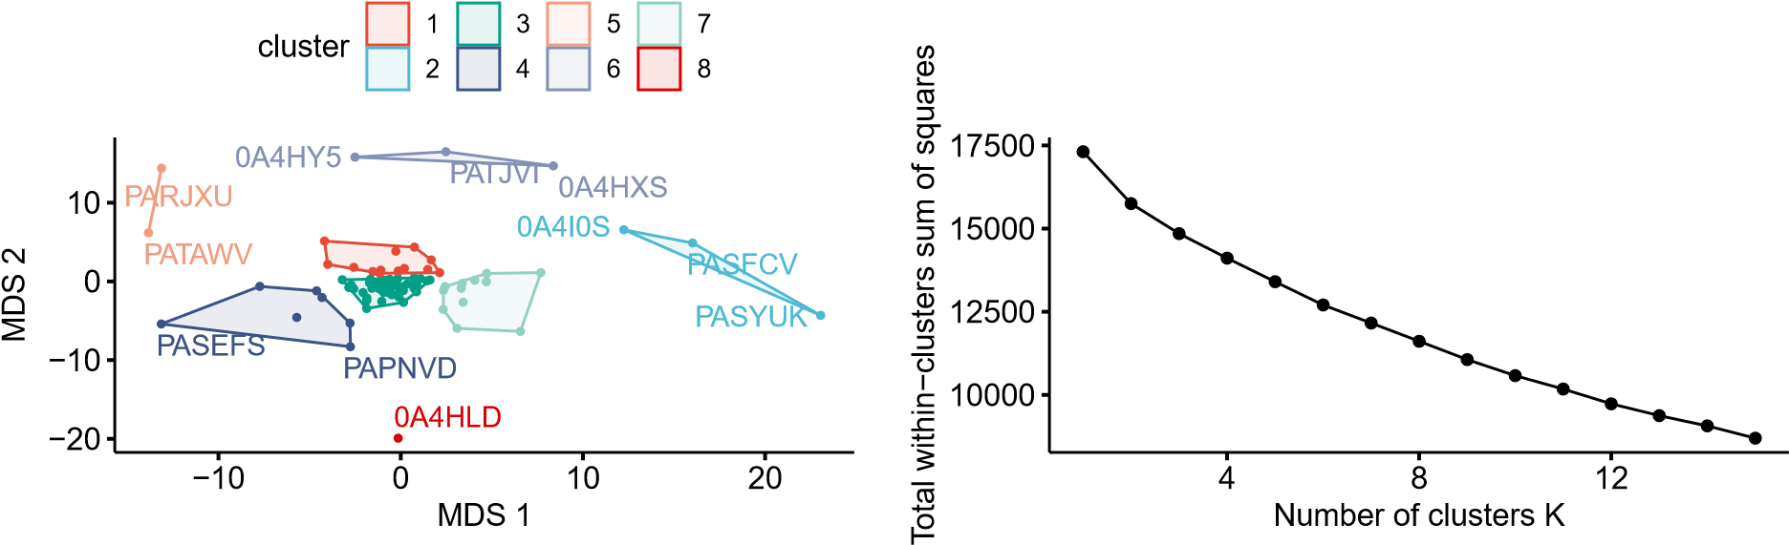

**C D**

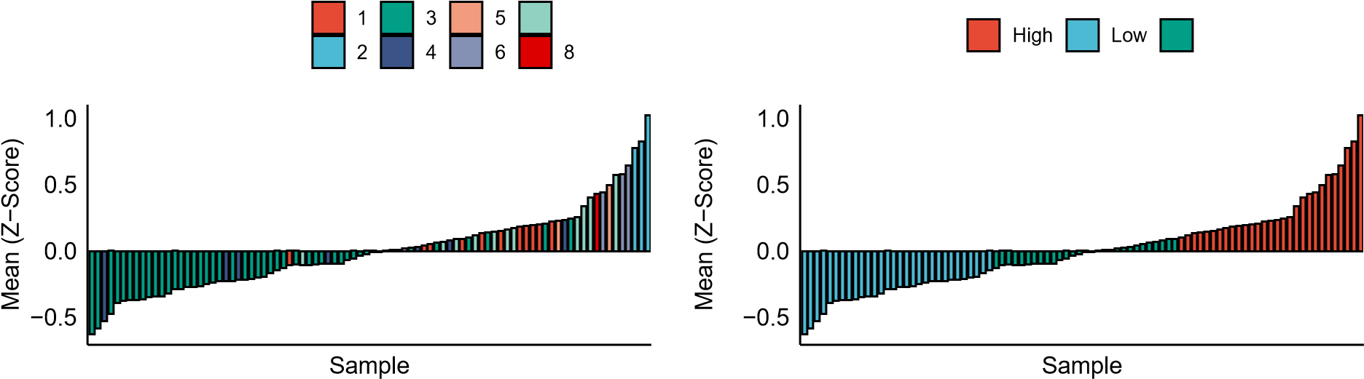7

MDS Cluster Group Medium

**E**

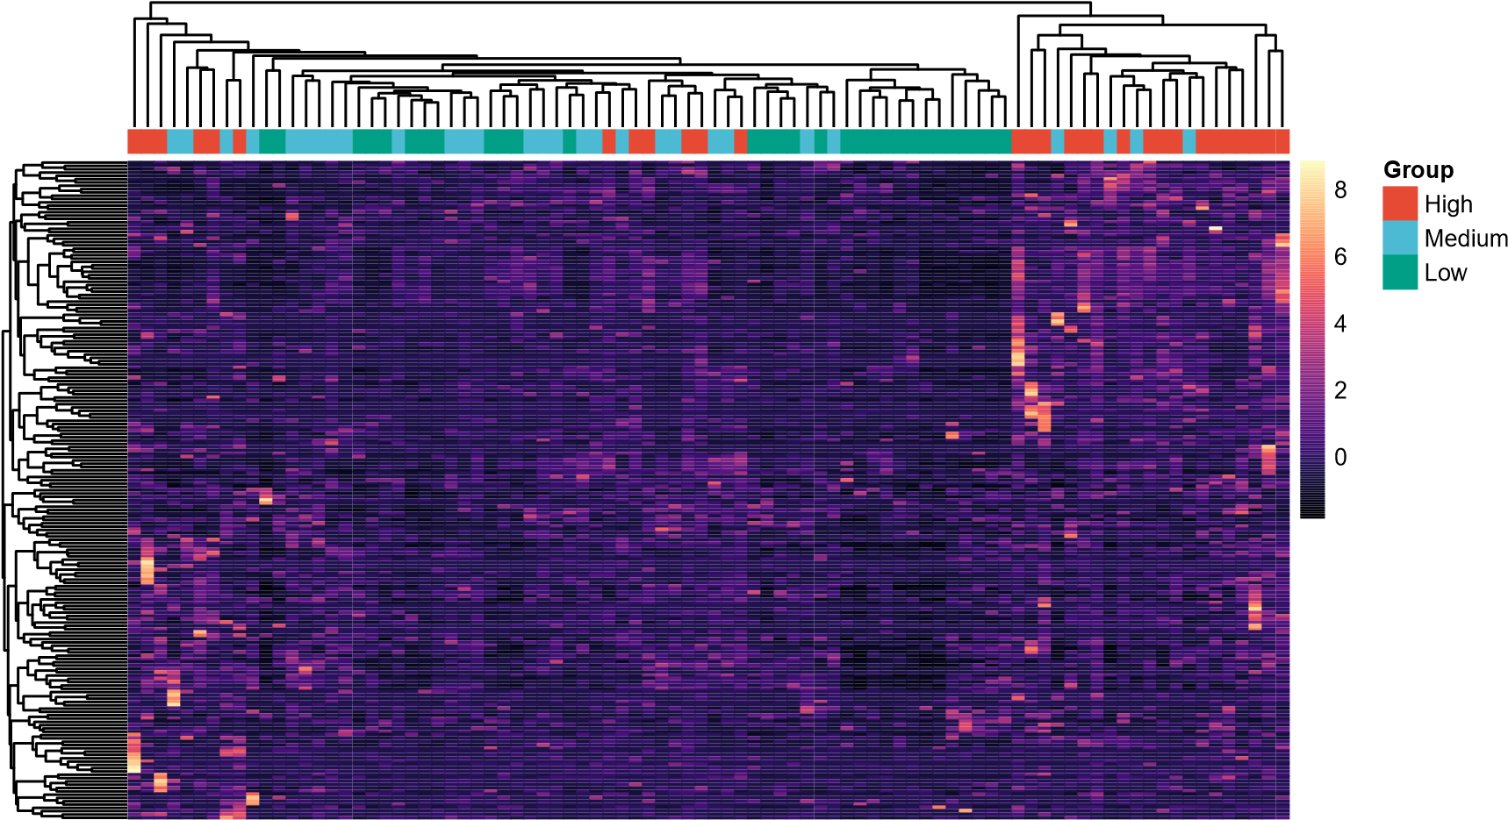

**Figure 1: Construction of inflammatory groups for the 88 samples in TARGET-OS dataset based on the HIR signature from MSigDB.**

1. MDS visualization with k-means clustering of the HIR signature. Data is Z-scaled.
2. Elbow graph determining the optimal number of k-clusters.
3. Histogram of the mean of Z-score of the HIR signature, annotated with the 8 k-means clusters.
4. Histogram of the mean of Z-score of the HIR signature, annotated with the 3 inflammatory status groups.(E) Heatmap of the HIR signature with samples annotated to their corresponding inflammatory groups. Rows correspond to genes and columns correspond to samples. Gene is expressed in TPM, Z-scaled. HIR = Hallmark Inflammatory Response. MDS = Multidimensional Scaling

**A B**

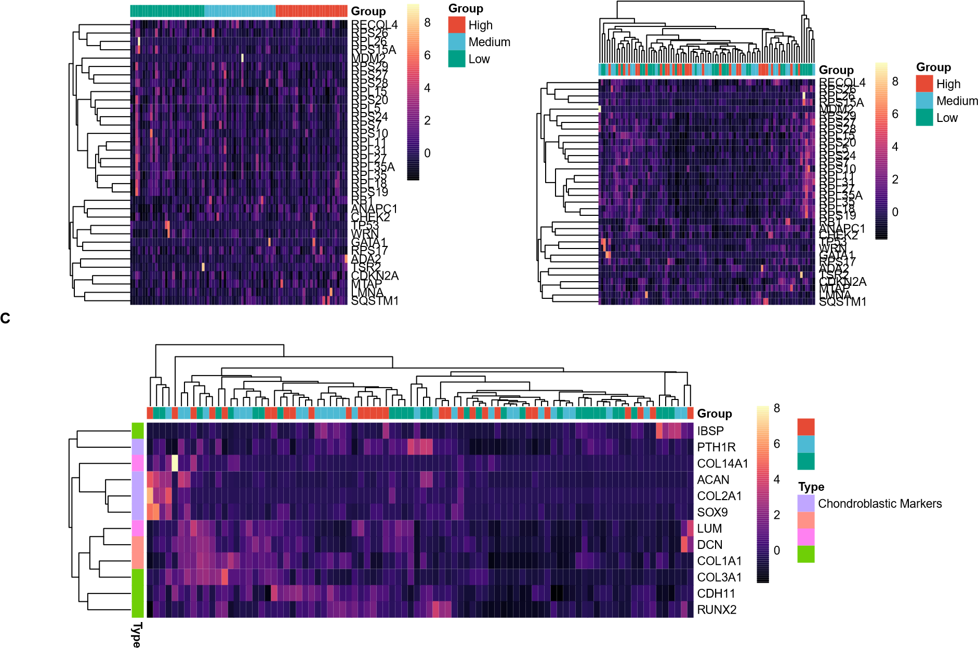**Group**

High

Medium

Low

Fibro−osteo Markers

Fibroblastic Markers

Osteoblastic Markers

**D**

p = 0.011

MKI67

PCNA

TOP2A

Low

Medium

High

Low

Medium

High

Low

Medium

High

0

250

500

750

1000

Group

TPM

Group

High

Medium

Low

Kruskal−Wallis, p = 0.092

**Figure 2: Displays of various osteosarcoma related genes with samples annotated to their respective inflammatory groups.** Values are Z-scaled for heatmaps.

1. Heatmap *Hp Osteosarcoma* signature with unclustered samples.
2. Heatmap of *Hp Osteosarcoma* with clustered samples.
3. Heatmap of osteosarcoma type markers.
4. Violin plot of proliferation markers associated with their inflammatory group.

distinct expression of genes in each inflammatory group.

To further characterize subtypes of osteosarcomas, comparison of the expression of specific osteosarcoma markers relating to osteoblastic, chondroblastic, fibroblastic markers has also been done, through a heatmap representation. Hierarchical clustering of the samples does not appear to be associated with corresponding inflammatory status. However it does reveal that there are groups of osteoblastic, chondroblastic and fibroblastic osteosarcomas which is expected **(Figure 2C)**.

To assess the proliferation status of the samples related to the inflammation status, the mean of three markers of proliferation (MKI67, PCNA, TOP2A) have been compared, along with the mean of the three individual markers **(Figure 2D)**. Statistical Kruskal-Wallis testing is significant (*P* = 0.00968) and post-hoc Dunn analysis reveals that the mean of the proliferation markers between low and high group is significantly different (*P* = 0.016). The data suggests that proliferation is hindered when inflammatory status is high in the osteosarcoma samples.

## Characterization of intra-tumor inflammation associated to inflammatory status

### Relationship with ESTIMATE and inflammatory signatures

Using the ESTIMATE algorithm, an immune score has been calculated for each sample which reflects the immune infiltration in a given tumor sample. The violin plot represents the values obtained for each inflammatory group **(Figure 3)**. Because the data is normally distributed and has homoscedasticity, ANOVA has been performed (*P* = 0.002) followed by Tukey’s test, revealing that there is a statistically significant difference between Low and High group (*P* = 0.002), but not for the other conditions.

### Immune abundance by immune deconvolution algorithm

Immune cell abundance can be determined by various immune deconvolution algorithm on TPM normalized bulk-RNASeq. Here, MCP-counter, CIBERSORTx and xCell have been tried. In MCP-

counter, the mean (SD) of Z-score reflecting the abundances of neutrophils is statistically different between all groups, it is increased when the inflammation status gets higher **(Figure 4A)**

Anova, p = 0.0022

p =

0.002

p = 0.065

p = 0.401

−2000

0

2000

4000

Low

Medium

High

Group

Immune Score

Group

High

Medium

Low

**Figure 3:** **Violin plot of ESTIMATE score for each inflammatory group.** ANOVA was performed followed by Tukey’s post-hoc analysis. 𝑃 ≤ 0.05 is considered statistically significant.

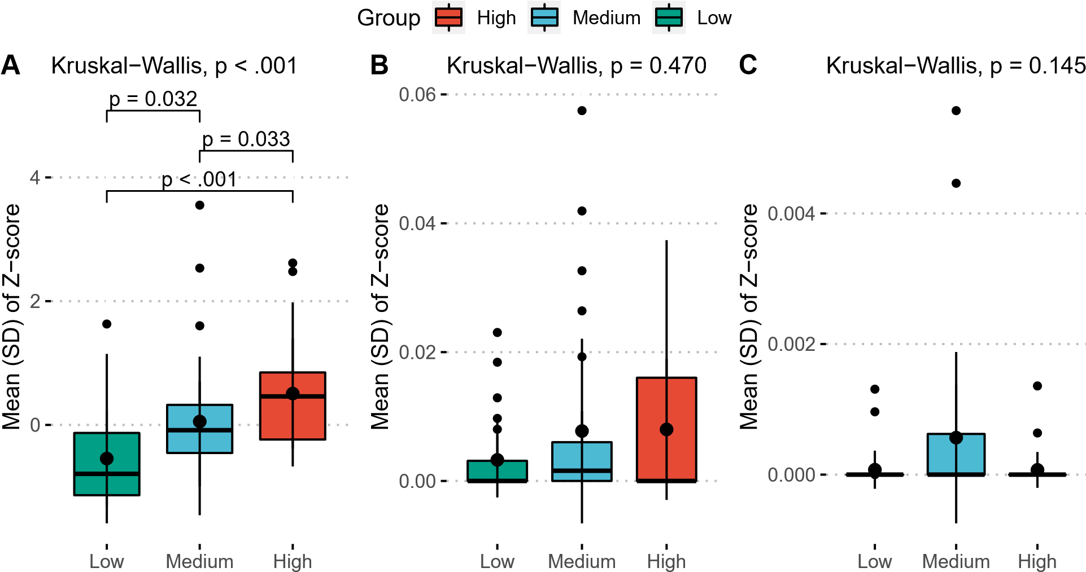

**Figure 4: Boxplot of the abundance of neutrophils with various immune deconvolution algorithm.** (A) MCP-counter.

1. CIBERSORTx.
2. xCell.

Kruskal-Wallis testing is performed on non-parametric data and a post-hoc dunn’s test was performed when appropriate. *P* ≤ 0.05 is considered statistically significant.

### Survival curve

In order to determine if inflammation groups are linked with increased survival odds, a KaplanMeier survival analysis was performed between low and high group of inflammation **(Figure 5)**. Log-rank analysis shows that the survival curve between low and high group of inflammation are not statistically different (*P* = 0.16). However the *P* value is low enough that it could be considered a trend. Estimation considers 29 patients in the low group and 28 patients in the high group, and estimates that only 9 patients remain alive in the low group while 20 patients are alive in the high

group.

+

+

+

+

+

+

+

+

+

+

+

+

+

+

+

+

+

+

+

+

+

+

+

+

+

+

+

+

p = 0.16

Log−rank

0.00

0.25

0.50

0.75

1.00

0

1000

Time

Survival probability

Strata

~~+~~

~~+~~

High

Low

Number at risk

Low 29

Strata

9

High 28 20

0 1000

Time

**Figure 5: Kaplan-Meier survival analysis plot of low vs high group indicate a trend associating inflammatory status with survival prognostic.** Horizontal and vertical axes represent survival times and rates, respectively. Blue and red colors represents low and high inflammation group respectively. Plus signs indicate censored values. Depicted P-values were obtained by the log-rank test. The diagram is cut at 1825 days (5 years). *P* ≤ 0.05 is considered statistically significant.

### Similarity of inflammatory signatures

In order to see if the inflammatory signatures used have overlapping genes or not, a Venn diagram was constructed from the signatures **(Figure 6**. Overall, the three immune signatures depicting immune infiltration (immune score), inflammation response and TNF-α pathway have low overlapping

genes and can be considered different.

count

ESTIMATE

116

(25%)

134

(29%)

145

(31%)

15

(3

%

)

4

(1

%

)

45

(10%)

6

(1

%

)

100

50

Hallmark Inflammatory Response TNF−a signaling

**Figure 6: Venn diagram comparing three inflammatory signatures.**. ESTIMATE refers to the immune score calculated by the ESTIMATE algorithm, reflecting mmune cell infiltration. Hallmark Inflammatory Response and TNF-α signature are hallmark signatures taken from MSigDB.

## Biological mechanisms underlying the inflammatory groups

### Differential Gene Expression Analysis and Enrichment

A differential gene expression analysis was performed on the inflammatory status condition (Low vs High) on the total 19114 genes. DEGs are enriched through multiple databases in order to identify potentially interesting pathways relating to a high level of inflammation **(Figure 7)**. Only relevant enrichment plots are shown. The combined enrichment barplot **(Figure 7A)** returned multiple pathways associated with chemokines, PD-1 signaling, and T cell lymphocyte associated mechanisms. Interestingly, enrichment of downregulated genes in GO Biological Process database returned a lot of pathways linked to immune cell chemotaxis, and particularly neutrophil chemotaxis.

**A**

0

500

1000

Term

Dopamine receptors Homo sapiens R−HSA−390651

Dopamine receptors

dopamine neurotransmitter receptor activity (GO:0004952)

CXCR3 chemokine receptor binding (GO:0048248)

PD−1 signaling Homo sapiens R−HSA−389948

Translocation of ZAP−70 to Immunological synapse Homo sapiens R−HSA−202430

positive regulation of CD4−positive, CD25−positive, alpha−beta regulatory T cell differentiation (GO:0032831)

chronic inflammatory response (GO:0002544)

T helper cell surface molecules

Lck and Fyn tyrosine kinases in initiation of T cell receptor activation

CTL mediated immune response against target cells

PD−1 signaling

Phosphorylation of CD3 and TCR zeta chains Homo sapiens R−HSA−202427

CXCR chemokine receptor binding (GO:0045236)

Interleukin−17 signaling pathway

Inhibition of T cell receptor signaling by activated Csk regulation of T−helper cell differentiation (GO:0045622)

prepulse inhibition (GO:0060134)

positive regulation of cell−cell adhesion mediated by integrin (GO:0033634)

cell junction disassembly (GO:0150146)

Combined.Score

database

Bio Planet 2019

Go Biological Process 2021

Go Molecular Function 2021

Reactome 2016

**B** Go Biological Process 2021

chronic inflammatory response (GO:0002544)

0

5

10

15

Gene count



1000

1500

Combined Score

Enriched terms

positive regulation of CD4−positive, CD25−positive, alpha−beta regulatory T cell differentiation (GO...

cell junction disassembly (GO:0150146)

positive regulation of cell−cell adhesion mediated by integrin (GO:0033634)

regulation of T−helper cell differentiation (GO:0045622)

positive regulation of chemokine (C−X−C motif) ligand 2 production (GO:2000343)

positive regulation of lymphocyte apoptotic process (GO:0070230)

neutrophil chemotaxis (GO:0030593) dendritic cell chemotaxis (GO:0002407) granulocyte chemotaxis (GO:0071621) neutrophil migration (GO:1990266)

negative regulation of interferon−gamma production (GO:0032689)

positive regulation of CD4−positive, alpha−beta T cell differentiation (GO:0043372)

immunological synapse formation (GO:0001771)

T−helper cell lineage commitment (GO:0002295) cellular response to chemokine (GO:1990869) dendritic cell migration (GO:0036336)

chemokine−mediated signaling pathway (GO:0070098) regulation of immune response (GO:0050776) complement activation, classical pathway (GO:0006958)

20

**Figure 7: Top 20 results of enrichment using enrichR for Low vs High condition.**

1. Combined enrichment for the 8 databases.
2. Enrichment for downregulated genes for GO Biological Process 2021 database.

### Gene Set Enrichment Analysis (GSEA)

GSEA was performed on 95 selected signatures from MSigDB, based on the theme of osteosarcoma, angiogenesis, neutrophils, migration, hypoxia and inflammation. Only significant pathways are reported in the **Table 1**. Certain pathways are not significant but relevant, such as “Gobp Positive Regulation of Vascular Associated Smooth Muscle Cell Proliferation” (*P* = 0.129), “Gobp Positive Regulation of Inflammatory Response” (*P* = 0.145), and all other pathways concerning dendritic,

lymphocyte, monocyte, macrophage chemotaxis and migration (*P* ≥ 0.150)

Interestingly, there is no found significant pathway relating to positive regulation of inflammation, but there are significant pathways relating to negative regulation of inflammation, indicating that in the high group, there is negative regulation of inflammation. Similarly, the only signature with a negative enrichment score is “Gobp Positive Regulation of Neutrophil Activation”. It is also notable that the signature *Hp Osteosarcoma* in GSEA is not significantly different (*P* = 0.38).

**Table 1:** Results of GSEA by clusterProfiler, pre-ranked by descending order of log2 of fold change for genes differentially expressed in low vs high condition. Genes at the top of the list are thus differentially expressed in the high group, and vice versa. Only significant pathways are shown, out of 95 selected pathways. 𝑃 adjust ≤ 0.10 is considered significant. NES = Normalized Enrichment Score

|  |  |  |  |  |
| --- | --- | --- | --- | --- |
| Pathway | Set Size | NES | p.adjust | p.sign |
| Gobp Cell Migration | 1431 | 1.401 | p < .001 | *** |
| Reactome Neutrophil Degranulation | 475 | 1.488 | p < .001 | *** |
| Hallmark Hypoxia | 199 | 1.557 | p < .001 | *** |
| Theilgaard Neutrophil at Skin Wound Dn | 226 | 1.560 | p < .001 | *** |
| Hay Bone Marrow Neutrophil | 439 | 1.385 | p < .001 | *** |
| Hallmark Inflammatory Response | 199 | 1.504 | p < .001 | *** |
| Hp Abnormality of Neutrophils | 267 | 1.461 | p < .001 | *** |
| Gobp Negative Regulation of Inflammatory Response | 144 | 1.512 | p = 0.001 | ** |
| Hp Abnormal Neutrophil Count | 189 | 1.460 | p = 0.001 | ** |
| Gobp Endothelial Cell Migration | 216 | 1.425 | p = 0.002 | ** |
| Kegg Leukocyte Transendothelial Migration | 113 | 1.500 | p = 0.004 | ** |
| Gobp Negative Regulation of Neuroinflammatory Response | 14 | 1.663 | p = 0.007 | ** |
| Wp Neovascularisation Processes | 37 | 1.571 | p = 0.023 | * |
| Gobp Sprouting Angiogenesis | 127 | 1.416 | p = 0.023 | * |
| Hallmark Tnfa Signaling via Nfkb | 200 | 1.344 | p = 0.023 | * |
| Theilgaard Neutrophil at Skin Wound Up | 75 | 1.485 | p = 0.026 | * |
| Travaglini Lung Neutrophil Cell | 332 | 1.230 | p = 0.038 | * |
| Gobp Negative Regulation of Neutrophil Activation | 5 | 1.497 | p = 0.038 | * |
| Sig Chemotaxis | 45 | 1.482 | p = 0.047 | * |
| Reactome Cellular Response to Hypoxia | 75 | 1.437 | p = 0.055 | * |
| Hay Bone Marrow Immature Neutrophil | 189 | 1.276 | p = 0.067 | * |
| Gobp Positive Regulation of Neutrophil Activation | 6 | -1.687 | p = 0.093 | * |
| Wp Angiogenesis | 24 | 1.455 | p = 0.093 | * |

# Discussion

the purpose of the discussion is to summarize your major findings and place them in the context of the current state of knowledge in the literature. When you discuss your own work and that of

others, back up your statements with evidence and citations.

* The first part of the discussion should contain a summary of your major findings (usually 2 – 4 points) and a brief summary of the implications of your findings. Ideally, it should make reference to whether you found support for your hypotheses or answered your questions that were placed at the end of the introduction.
* The following paragraphs will then usually describe each of these findings in greater detail, making reference to previous studies.
* Often the discussion will include one or a few paragraphs describing the limitations of your study and the potential for future research.
* Subheadings within the discussion can be useful for orienting the reader to the major themes

that are addressed.

## Limitations

* Immune deconvolutions methods do not give the same results, thus they are unclear. Only MCP Counter reports significantly different neutrophil abundance between low and high

group.

* Immune deconv paper has 7 limitations (Sturm et al., 2019).
* Z-score and equal mean of groups may not be the best normalization method and way of making groups. Geometric mean (inspired from a package) could have been used but returned 0 value despite all values being positive.
* Literature analysis comparing normalization methods reveals library size normalization (TPM, FPKM, RPKM) methods perform worse than distribution normalization methods (DESeq2, TMM), which are recommended by Zhao et al. (2021). Notably, library size normalization methods assume that the total amount of mRNA per cell is identical in every

condition.

* DESeq2’s normalized count could have then been used, as it is possible to get it from rawcounts after performing DESeq2 analysis, using two functions, estimateSizeFactors and counts(normalized = TRUE). However some immune deconvolution methods still expect TPM as input.
* Using DESeq2’s normalized raw count as input, it is inconsistent to then use TPM in order

to perform other analysis.

* Perhaps some outliers could have been removed in order to better identify clusters.
* In single-cell, one potential reason that we do not find neutrophils is because chemotherapy induces aplasia which kills off all short lives immune cells.
* Données de littérature peu nombreuses sur ostéosarcomes car cancer rare, cohorte petite et plus petite dans GSE87686
* Nouvelle cohorte de IGR
* Using mean could have resulted in a less precise formation of groups as the distribution of our samples regarding the inflammatory score was not normal. Thus groups based on the median or the quartiles of the median values of inflammatory samples could have been more

appropriate.

# Bibliography

Abrams, Z.B., Johnson, T.S., Huang, K., Payne, P.R.O., and Coombes, K. (2019). [A protocol to evaluate RNA sequencing normalization methods](https://doi.org/10.1186/s12859-019-3247-x). BMC Bioinformatics *20*, 679.

Becht, E., Giraldo, N.A., Lacroix, L., Buttard, B., Elarouci, N., Petitprez, F., Selves, J., LaurentPuig, P., Sautès-Fridman, C., Fridman, W.H., et al. (2016). [Estimating the population abundance of tissue-infiltrating immune and stromal cell populations using gene expression](https://doi.org/10.1186/s13059-016-1070-5). Genome Biology *17*, 218.

Faget, J., Peters, S., Quantin, X., Meylan, E., and Bonnefoy, N. (2021). [Neutrophils in the era of immune checkpoint blockade](https://doi.org/10.1136/jitc-2020-002242). Journal for Immunotherapy of Cancer *9*, e002242.

Fu, Y., Jin, Z., Shen, Y., Zhang, Z., Li, M., Liu, Z., He, G., Wu, J., Wen, J., Bao, Q., et al. (2022). [Construction and validation of a novel apoptosis-associated prognostic signature related to osteosarcoma metastasis and immune infiltration](https://doi.org/10.1016/j.tranon.2022.101452). Translational Oncology *22*, 101452.

Jawaid, W. (2021). [enrichR: Provides an r interface to enrichr](https://CRAN.R-project.org/package=enrichR).

Long, W., Chen, J., Gao, C., Lin, Z., Xie, X., and Dai, H. (2021). [Brief review on the roles of neutrophils in cancer development](https://doi.org/10.1002/jlb.4mr0820-011r). Journal of Leukocyte Biology *109*, 407–413.

Love, M.I., Huber, W., and Anders, S. (2014). [Moderated estimation of fold change and dispersion for RNA-seq data with DESeq2](https://doi.org/10.1186/s13059-014-0550-8). Genome Biology *15*, 550.

Mirabello, L., Troisi, R.J., and Savage, S.A. (2009). [Osteosarcoma incidence and survival rates from 1973 to 2004](https://doi.org/10.1002/cncr.24121). Cancer *115*, 1531–1543.

Sturm, G., Finotello, F., Petitprez, F., Zhang, J.D., Baumbach, J., Fridman, W.H., List, M., and Aneichyk, T. (2019). [Comprehensive evaluation of transcriptome-based cell-type quantification methods for immuno-oncology](https://doi.org/10.1093/bioinformatics/btz363). Bioinformatics *35*, i436–i445.

Xie, Z., Bailey, A., Kuleshov, M.V., Clarke, D.J.B., Evangelista, J.E., Jenkins, S.L., Lachmann, A., Wojciechowicz, M.L., Kropiwnicki, E., Jagodnik, K.M., et al. (2021). [Gene Set Knowledge Discovery with Enrichr](https://doi.org/10.1002/cpz1.90). Current Protocols *1*, e90.

Zhao, Y., Li, M.-C., Konaté, M.M., Chen, L., Das, B., Karlovich, C., Williams, P.M., Evrard, Y.A., Doroshow, J.H., and McShane, L.M. (2021). [TPM, FPKM, or Normalized Counts? A Comparative Study of Quantification Measures for the Analysis of RNA-seq Data from the NCI Patient-Derived Models Repository](https://doi.org/10.1186/s12967-021-02936-w). Journal of Translational Medicine *19*, 269.

Zhou, Y., Yang, D., Yang, Q., Lv, X., Huang, W., Zhou, Z., Wang, Y., Zhang, Z., Yuan, T., Ding,

X., et al. (2020). [Single-cell RNA landscape of intratumoral heterogeneity and immunosuppressive microenvironment in advanced osteosarcoma](https://doi.org/10.1038/s41467-020-20059-6). Nature Communications *11*, 6322.

# Appendix: code

Analyses were conducted using the R Statistical language (version 4.2.1; R Core Team, 2021) on Windows 11 x64. Code is available at [*https://github.com/Minh-AnhHuynh/Osteosarcoma-Project*](https://github.com/Minh-AnhHuynh/Osteosarcoma-Project).

) %>%

|  |
| --- |
| *# Load imported data*  data_path <- "../TargetOS-Osteosarcoma/03_results/TARGET-OS_GDC_protein_data.tsv" global_data <- vroom(data_path) %>% column_to_rownames("hgnc_symbol") %>% t() %>% as.data.frame()  *# Transform data in Z-scale* global_data_scaled <- global_data %>% rownames_to_column(var = "sample") %>% dplyr::select(-sample) %>% scale(center = TRUE, scale = TRUE) %>% bind_cols("sample" = row.names(global_data)) %>%  column_to_rownames("sample")  global_data_scaled %<>% .[, colSums(is.na(.)) < nrow(.)] *# Should be obsolete*  remove_genes <- remove_unknown_genes(get_list_unknown_genes = TRUE) %>% extract2("Hallmark_Inflammatory_Response")  *# Read data and remove unknown genes*  hallmark_inflammatory <- vroom("02_data/msigdb_signature/msigdb_signature.tsv" filter( gs_name == "hallmark_inflammatory_response",  !gene_symbol %in% remove_genes  ) hallmark_inflammatory <- global_data_scaled[, hallmark_inflammatory$  *# Construction of groups by mean of Z-score* hallmark_mean_groups <- hallmark_inflammatory %>% rownames_to_column("sample") %>% pivot_longer(!1, names_to = "markers") %>% group_by(sample) %>% summarise( median = median(value), mean = mean(value)  ) %>%  mutate(group_mean = as.factor(ntile(mean, 3))) %>% arrange(group_mean) |

gene_symbol]

|  |
| --- |
| *# dplyr::ntile splits input vector into n even groups*  *# Rename numbers to Low, Medium and High group*  hallmark_mean_groups %<>% mutate( group_mean = str_replace(group_mean, "1", "Low"), group_mean = str_replace(group_mean, "2", "Medium"), group_mean = str_replace(group_mean, "3", "High"),  ) %>% write_tsv("03_results/hallmark_mean_groups.tsv")  *# Compute hallmark_mean_groups for heatmap*  mds_data <- hallmark_heatmap(k_cluster = 8, scale = TRUE) hallmark_cluster <- mds_data %>% dplyr::select(sample, cluster) %>% arrange(cluster) %>%  dplyr::rename(cluster_8 = cluster)  hallmark_mean_groups %<>% left_join(hallmark_cluster) %>% arrange(mean)  *# Histogram of hallmark mean with MDS clusters* hmg_mds_8 <- ggbarplot(hallmark_mean_groups,  x = "sample", y = "mean", xlab = "Sample", ylab = "Mean (Z-Score)", fill = "cluster_8", palette = "npg",  legend.title = "MDS Cluster",  ) +  theme( axis.ticks = element_blank(), axis.text.x = element_blank()  ) ggsave("04_figures/ggplot/hallmark_mean_vs_sample+MDS_8_clusters.png",  dpi = "retina"  )  ***## Histogram of hallmark groups of inflammation ====***  hmg <- ggbarplot(hallmark_mean_groups,  x = "sample", y = "mean", xlab = "Sample", |

)

) %>%

|  |
| --- |
| ylab = "Mean (Z-Score)", fill = "group_mean", palette = "npg",  legend.title = "Group"  ) +  theme( axis.ticks = element_blank(), axis.text.x = element_blank()  ) ggsave("04_figures/ggplot/hallmark_mean_vs_sample+group_mean.png",  dpi = "retina"  )  ***### Compute kruskal test ####***  stat_table <- make_mean_comparison(hallmark_mean_groups, "mean", "group_mean"  *# Compute elbow, mds and heatmap*  elbow_hi <- elbow_method(hallmark_inflammatory)  mds_8 <- hallmark_heatmap(k_cluster = 8, scale = TRUE, return_plot = TRUE)  *# Compute heatmap*  hallmark_annotation <- hallmark_mean_groups %>% column_to_rownames("sample") %>% select("Group" = "group_mean") %>%  `levels<-`(c("Low", "Medium", "High"))  hallmark_inflammatory <- vroom("02_data/msigdb_signature/msigdb_signature.tsv" filter( gs_name == "hallmark_inflammatory_response",  !gene_symbol %in% remove_genes  ) hallmark_inflammatory <- global_data_scaled[, hallmark_inflammatory$ t()  hallmark_inflammatory <- hallmark_inflammatory[, match( row.names(hallmark_annotation), colnames(hallmark_inflammatory)  )]  ***### Colors for pheatmap group mean annotation ####*** gm_colors <- list("Group" = c(  "High" = ggsci::pal_npg()(3)[1], |

gene_symbol] %>%

|  |
| --- |
| "Medium" = ggsci::pal_npg()(3)[2],  "Low" = ggsci::pal_npg()(3)[3]  ))  ph <- pheatmap( hallmark_inflammatory,  annotation_col = hallmark_annotation, main = " ",  annotation_names_col = FALSE, annotation_colors = gm_colors, labels_row = "Gene", angle_col = "0", color = magma(256), cluster_cols = TRUE, show_colnames = FALSE, show_rownames = FALSE, cluster_rows = TRUE, border_color = NA, width = 15, filename = glue(  "04_figures/pheatmap/pheatmap-hallmark_group_mean_cluster_cols.png"  )  )  ph <- as.ggplot(ph) *# Transform pheatmap intp a ggplot object*  *# p <- ggarrange(elbow_hi, mds_8[[2]], hmg, hmg_mds_8, labels = "AUTO") #*  *# suppressWarnings(print(p)) # Used to suppress ggrepel warnings*  *# ggarrange(ph, labels = ("E"))*  patchwork <- mds_8[[2]] + elbow_hi + hmg_mds_8 + hmg + ph layout <- "  AAABBB  CCCDDD  EEEEEE"  patchwork <- patchwork +  plot_layout(design = layout, heights = c(1, 1, 3)) +  plot_annotation(tag_levels = "A") &  theme(plot.tag = element_text(face = "bold"))  *# <<hp_osteosarcoma>>*  *# <<mcp_counter>>*  *# <<survival_code>>*  *# <<load_deseq2>>*  *# <<generate_raw_count>>*  *# <<deseq2>>* |

|  |
| --- |
| *# 1. Setup ----------------------------------------------------------------*  librarian::shelf( tidyverse, glue, magrittr, msigdbr, fgsea, clusterProfiler, enrichplot, snakecase, ggridges, vroom  )  *# Read data* data <vroom("03_results/DESeq2_genes/DEG_results/DESeq2_inflammation_TARGET-OS.tsv"  data_low_vs_high <data %>% filter(df_name == "DESeq2_group_mean_Low_vs_High_df") *# %>%*  *# filter(gene %in% hallmark_inflammatory)*  *# Note that ICAM4 doesn't appear thus we have a gene list of 199 genes* gene_list_inflam <- data_low_vs_high %>% drop_na(log2FoldChange) %>% select(gene, log2FoldChange)  *# The log2FC of all genes is sorted from high to low, in order to input a pre-ranked in* gene_list_inflam %<>% pull(log2FoldChange) %>% sort(decreasing = TRUE) %>% set_names(gene_list_inflam$gene)  gene_list_diap <- vroom("03_results/DESeq2_genes/DEG_results/DESeq2_diapedesis_TARGET-OS dplyr::select(gene, log2FoldChange)  gene_list_diap %<>% pull(log2FoldChange) %>% sort(decreasing = TRUE) %>% set_names(gene_list_diap$gene)  *# 2. msigdbr --------------------------------------------------------------* |

)

|  |
| --- |
| *# Get pathway from source "01_script/get_msigdb_signature.R"* msigdb_files <list.files("02_data/msigdb_signature/", full.names = TRUE)  all_signatures <- msigdb_files %>% map(vroom) %>%  set_names(basename(tools::file_path_sans_ext(msigdb_files)))  *# Make GSEA and GSEA Table*  make_gsea_clusterProfiler <**function**(gene_list, msigdb_signature,  dir_save = "04_figures/GSEA/clusterProfiler/",  get_gsea_plot = FALSE) { *# Traditional running enrichment score* msigdb_signature_df <- bind_rows(msigdb_signature)  set.seed(123) gsea_msig <-  GSEA( gene_list,  TERM2GENE = msigdb_signature_df,  minGSSize = 1, maxGSSize = 10000, verbose = TRUE, seed = TRUE, by = "fgsea", pvalueCutoff = 1  *# adjusted pvalue cutoff to allow every signatures in @result tab* )  **if** (get_gsea_plot == TRUE) {  *# Single GSEA plot for each gene set* gsea_msig@result[["ID"]] %>% map2(seq_along(.), ~ { gseaplot2( gsea_msig, geneSetID = .y, title = glue("{.x}"), pvalue_table = TRUE  )  dir.create(dir_save, showWarnings = FALSE) ggsave(glue("{dir_save}GSEA-{.x}.png"), width = 10) print(glue("Single GSEA plot saved for {.x}")) }) |

|  |
| --- |
| }  *# Combined GSEA plot for each separate element in msigdb_signature list* iwalk(msigdb_signature, ~ { signature_group <- distinct(., gs_name) %>% pull()  signature_index_id <- which(gsea_msig@result[["ID"]] %in% signature_group) gseaplot2( gsea_msig,  geneSetID = signature_index_id, title = glue("{.y}"), pvalue_table = TRUE  )  dir.create(glue("{dir_save}combined_GSEA/"), showWarnings = FALSE) ggsave(glue("{dir_save}combined_GSEA/GSEA_combined-{.y}.png"),  width = 12  )  print(glue("Combined GSEA plot saved for {.y}"))  })  *# Ridgeplot*  ridgeplot(gsea_msig, orderBy = "NES", decreasing = TRUE) dir.create(glue("{dir_save}ridgeplot/"), showWarnings = FALSE) ggsave(glue("{dir_save}ridgeplot/GSEA-ridgeplot.png")) print(glue("Ridge plot"))  *# Make p significant table for easy visualization*  gsea_msig_sign <- gsea_msig@result %>% rownames_to_column("Pathway") %>% mutate(  p.sign = case_when(  p.adjust <= 0.001 ~ "***",  p.adjust <= 0.01 ~ "**",  p.adjust <= 0.1 ~ "*", TRUE ~ "ns"  ),  Pathway = to_title_case(Pathway)  ) %>%  dplyr::select(Pathway,  "Set Size" = setSize,  NES,  p.adjust, qvalues,  p.sign  ) dir.create(glue("{dir_save}GSEA_table/"), showWarnings = FALSE) |
| *# Do a separate table for each sublist with p.sign*  iwalk(msigdb_signature, ~ { signature_group <- distinct(.x, gs_name) %>% pull() %>% to_title_case()  html_file <- glue("{dir_save}GSEA_table/GSEA_table-{.y}.html") gsea_msig_sign %>% filter(Pathway %in% signature_group) %>% kableExtra::kbl("html") %>% kableExtra::kable_styling() %>% kableExtra::save_kable(html_file)  *# Instead of using save_kable to png directly, which doesn't work, we use a*  *# workaround by saving html first and using webshot to save png, which is what*  *# the function is supposed to do automatically anyway* webshot::webshot( html_file,  glue("{dir_save}GSEA_table/GSEA_table_sign-{.y}.png")  )  print(glue("GSEA Table saved for {.y} in {dir_save}GSEA_table/."))  })  return(gsea_msig_sign) }  gsea_df <- make_gsea_clusterProfiler(gene_list_inflam, all_signatures, dir_save = "04_figures/GSEA/inflammation/clusterProfiler/" ) |

## - Session info --------------------------------------------------------------## setting value

## version R version 4.2.1 (2022-06-23 ucrt)

## os Windows 10 x64 (build 22621)

## system x86_64, mingw32

## ui RTerm

|  |  |
| --- | --- |
| ## package | * version date (UTC) lib source |
| ## assertthat | * 0.2.1 2019-03-21 [1] CRAN (R 4.2.1) |
| ## Biobase | * 2.56.0 2022-04-26 [1] Bioconductor |

## language (EN)

## collate French_France.utf8

## ctype French_France.utf8

## tz Europe/Paris

## date 2022-07-19

## pandoc 2.17.1.1 @ C:/Program Files/RStudio/bin/quarto/bin/ (via rmarkdown) ##

## - Packages -------------------------------------------------------------------

|  |  |
| --- | --- |
| ## BiocGenerics | * 0.42.0 2022-04-26 [1] Bioconductor |
| ## BiocManager | * 1.30.18 2022-05-18 [1] CRAN (R 4.2.0) |
| ## bookdown | * 0.27 2022-06-14 [1] CRAN (R 4.2.1) |
| ## car | * 3.1-0 2022-06-15 [1] CRAN (R 4.2.1) |
| ## carData | * 3.0-5 2022-01-06 [1] CRAN (R 4.2.1) |
| ## data.table | * 1.14.2 2021-09-27 [1] CRAN (R 4.2.1) |
| ## DESeq2 | * 1.36.0 2022-04-26 [1] Bioconductor |
| ## dplyr | * 1.0.9 2022-04-28 [1] CRAN (R 4.2.0) |
| ## EnhancedVolcano | * 1.14.0 2022-04-26 [1] Bioconductor |
| ## enrichR | * 3.0 2021-02-02 [1] CRAN (R 4.2.1) |
| ## forcats | * 0.5.1 2021-01-27 [1] CRAN (R 4.2.1) |
| ## GenomeInfoDb | * 1.32.2 2022-05-15 [1] Bioconductor |
| ## GenomicRanges | * 1.48.0 2022-04-26 [1] Bioconductor |
| ## ggplot2 | * 3.3.6 2022-05-03 [1] CRAN (R 4.2.1) |
| ## ggplotify | * 0.1.0 2021-09-02 [1] CRAN (R 4.2.1) |
| ## ggpmisc | * 0.4.7 2022-06-15 [1] CRAN (R 4.2.1) |
| ## ggpp | * 0.4.4 2022-04-10 [1] CRAN (R 4.2.1) |
| ## ggpubr | * 0.4.0 2020-06-27 [1] CRAN (R 4.2.1) |
| ## ggrepel | * 0.9.1 2021-01-15 [1] CRAN (R 4.2.1) |
| ## ggVennDiagram | * 1.2.0 2021-10-22 [1] CRAN (R 4.2.1) |
| ## glue | * 1.6.2 2022-02-24 [1] CRAN (R 4.2.0) |
| ## gridExtra | * 2.3 2017-09-09 [1] CRAN (R 4.2.1) |
| ## IRanges | * 2.30.0 2022-04-26 [1] Bioconductor |
| ## kableExtra | * 1.3.4 2021-02-20 [1] CRAN (R 4.2.1) |
| ## knitr | * 1.39 2022-04-26 [1] CRAN (R 4.2.0) |
| ## magrittr | * 2.0.3 2022-03-30 [1] CRAN (R 4.2.0) |
| ## Matrix | * 1.4-1 2022-03-23 [2] CRAN (R 4.2.1) |
| ## MatrixGenerics | * 1.8.1 2022-06-30 [1] Bioconductor |
| ## matrixStats | * 0.62.0 2022-04-19 [1] CRAN (R 4.2.1) |
| ## moments | * 0.14.1 2022-05-02 [1] CRAN (R 4.2.0) |
| ## msigdbr | * 7.5.1 2022-03-30 [1] CRAN (R 4.2.1) |
| ## patchwork | * 1.1.1 2020-12-17 [1] CRAN (R 4.2.1) |
| ## pheatmap | * 1.0.12 2019-01-04 [1] CRAN (R 4.2.1) |
| ## purrr | * 0.3.4 2020-04-17 [1] CRAN (R 4.2.0) |
| ## ragg | * 1.2.2 2022-02-21 [1] CRAN (R 4.2.1) |
| ## readr | * 2.1.2 2022-01-30 [1] CRAN (R 4.2.1) |
| ## rmarkdown | * 2.14 2022-04-25 [1] CRAN (R 4.2.0) |
| ## RSQLite | * 2.2.14 2022-05-07 [1] CRAN (R 4.2.1) |
| ## rstatix | * 0.7.0 2021-02-13 [1] CRAN (R 4.2.1) |
| ## S4Vectors | * 0.34.0 2022-04-26 [1] Bioconductor |
| ## sessioninfo | * 1.2.2 2021-12-06 [1] CRAN (R 4.2.1) |
| ## snakecase | * 0.11.0 2019-05-25 [1] CRAN (R 4.2.1) |
| ## stringr | * 1.4.0 2019-02-10 [1] CRAN (R 4.2.0) |

|  |  |  |
| --- | --- | --- |
| ## tibble | * 3.1.7 | 2022-05-03 [1] CRAN (R 4.2.0) |
| ## tidyestimate | * 1.1.0 | 2021-09-09 [1] CRAN (R 4.2.1) |
| ## tidyr | * 1.2.0 | 2022-02-01 [1] CRAN (R 4.2.1) |

## SummarizedExperiment * 1.26.1 2022-04-29 [1] Bioconductor

|  |  |
| --- | --- |
| ## tidyverse | * 1.3.1 2021-04-15 [1] CRAN (R 4.2.1) |
| ## uwot | * 0.1.11 2021-12-02 [1] CRAN (R 4.2.1) |
| ## viridis | * 0.6.2 2021-10-13 [1] CRAN (R 4.2.1) |
| ## viridisLite | * 0.4.0 2021-04-13 [1] CRAN (R 4.2.1) |
| ## vroom | * 1.5.7 2021-11-30 [1] CRAN (R 4.2.1) |

##

## [1] C:/Users/Minh-Anh/AppData/Local/R/win-library/4.2

## [2] C:/Program Files/R/R-4.2.1/library

##

## ------------------------------------------------------------------------------

|  |  |  |
| --- | --- | --- |
| Package | Version | Source |
| assertthat | 0.2.1 | CRAN (R 4.2.1) |
| Biobase | 2.56.0 | Bioconductor |
| BiocGenerics | 0.42.0 | Bioconductor |
| BiocManager | 1.30.18 | CRAN (R 4.2.0) |
| bookdown | 0.27 | CRAN (R 4.2.1) |
| car | 3.1.0 | CRAN (R 4.2.1) |
| carData | 3.0.5 | CRAN (R 4.2.1) |
| data.table | 1.14.2 | CRAN (R 4.2.1) |
| DESeq2 | 1.36.0 | Bioconductor |
| dplyr | 1.0.9 | CRAN (R 4.2.0) |
| EnhancedVolcano | 1.14.0 | Bioconductor |
| enrichR | 3.0 | CRAN (R 4.2.1) |
| forcats | 0.5.1 | CRAN (R 4.2.1) |
| GenomeInfoDb | 1.32.2 | Bioconductor |
| GenomicRanges | 1.48.0 | Bioconductor |
| ggplot2 | 3.3.6 | CRAN (R 4.2.1) |
| ggplotify | 0.1.0 | CRAN (R 4.2.1) |
| ggpmisc | 0.4.7 | CRAN (R 4.2.1) |
| ggpp | 0.4.4 | CRAN (R 4.2.1) |
| ggpubr | 0.4.0 | CRAN (R 4.2.1) |
| ggrepel | 0.9.1 | CRAN (R 4.2.1) |
| ggVennDiagram | 1.2.0 | CRAN (R 4.2.1) |
| glue | 1.6.2 | CRAN (R 4.2.0) |
| gridExtra | 2.3 | CRAN (R 4.2.1) |
| IRanges | 2.30.0 | Bioconductor |
| kableExtra | 1.3.4 | CRAN (R 4.2.1) |
| knitr | 1.39 | CRAN (R 4.2.0) |
| magrittr | 2.0.3 | CRAN (R 4.2.0) |
| Matrix | 1.4.1 | CRAN (R 4.2.1) |
| MatrixGenerics | 1.8.1 | Bioconductor |
| matrixStats | 0.62.0 | CRAN (R 4.2.1) |
| moments | 0.14.1 | CRAN (R 4.2.0) |
| msigdbr | 7.5.1 | CRAN (R 4.2.1) |
| patchwork | 1.1.1 | CRAN (R 4.2.1) |

|  |  |  |
| --- | --- | --- |
| Package | Version | Source |
| pheatmap | 1.0.12 | CRAN (R 4.2.1) |
| purrr | 0.3.4 | CRAN (R 4.2.0) |
| ragg | 1.2.2 | CRAN (R 4.2.1) |
| readr | 2.1.2 | CRAN (R 4.2.1) |
| rmarkdown | 2.14 | CRAN (R 4.2.0) |
| RSQLite | 2.2.14 | CRAN (R 4.2.1) |
| rstatix | 0.7.0 | CRAN (R 4.2.1) |
| S4Vectors | 0.34.0 | Bioconductor |
| sessioninfo | 1.2.2 | CRAN (R 4.2.1) |
| snakecase | 0.11.0 | CRAN (R 4.2.1) |
| stringr | 1.4.0 | CRAN (R 4.2.0) |
| SummarizedExperiment | 1.26.1 | Bioconductor |
| tibble | 3.1.7 | CRAN (R 4.2.0) |
| tidyestimate | 1.1.0 | CRAN (R 4.2.1) |
| tidyr | 1.2.0 | CRAN (R 4.2.1) |
| tidyverse | 1.3.1 | CRAN (R 4.2.1) |
| uwot | 0.1.11 | CRAN (R 4.2.1) |
| viridis | 0.6.2 | CRAN (R 4.2.1) |
| viridisLite | 0.4.0 | CRAN (R 4.2.1) |
| vroom | 1.5.7 | CRAN (R 4.2.1) |

# Summary

English Summary no more than 250 words for the abstract

* a description of the research question/knowledge gap – what we know and what we don’t know
* how your research has attempted to fill this gap
* a brief description of the methods
* brief results
* key conclusions that put the research into a larger context